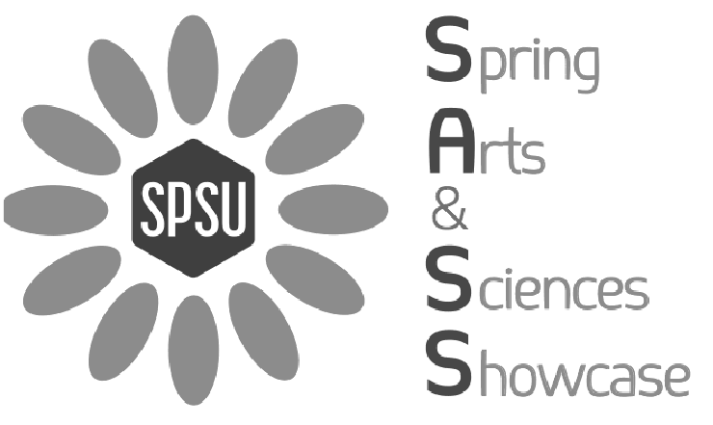

SPSU Arts & Sciences Showcase Week of April 17-April 23

April 17-26: 6th Annual Honors Comp II: Photo Exhibition and Sale (Student Center & J Building)

April 18-23: School of Arts and Sciences Poster Contest: Student Center

April 19: SPSU Band Concert dedicated to Prof. Jack Haley: 4:30pm Student Center Theatre (bring your dancing shoes)
Light refreshments to be served after band concert

April 20: A&S Showcase: 1-4pm Student Center Ballroom

